BCA Optimized Notes by Yash

Semester IV **- Computer Networking**

Table of Contents

# Unit 1

## Networks

A computer network is a system that connects two or more computing devices for transmitting and sharing information.

* **ARPANET**
  + ARPANET (Advanced Research Projects Agency Network) was the first wide-area packet-switched network with distributed control and one of the first computer networks to implement the TCP/IP protocol suite.
  + Both technologies became the technical foundation of the Internet.
* **OSI**
  + OSI (Open System Interconnection) is a layered structure for network communication.
  + It was later changed to ISO, i.e. International Standard Organization.

## Standards

In networking, standards provide a set of guidelines.

* **ANSI**
  + The ANSI (American National Standards Institute) is a private non-profit organization that oversees the development of various standards in the United States of America.
* **Manufacturing Standards**
  + There are two standards provided by manufacturers, namely De Facto and De Jure.
  + The De Facto standards are based on factors, while De Jure standards are approved by the government.
* **Other Standards**
  + The IEEE (Institute of Electrical and Electronics Engineers) standards are used by engineers.
  + The ITU-T (International Telecommunication Union Telecommunication Standardization Sector) standards are used for telecommunication.
  + The CCITT (Consultative Committee for International Telegraphy and Telephony) standards were earlier versions of the ITU-T standards.
  + The EIA (Electronic Industries Association) standards are used for electronic devices.

## Protocols

In networking, protocols provide a set of rules.

### Key Elements

* **Syntax**  
  Provides structure
* **Semantic**  
  Provides formatting
* **Timelines**  
  Manages the timing

### Various Protocols

* **ICANN**
  + ICANN (Internet Corporation for Assigned Names and Numbers) is the non-profit corporation that oversees IP address allocation, protocol parameters, DNS (Domain Name System) management, and root server functions.
  + The IANA (Internet Assigned Number Authority) previously performed these services.
* **TCP/IP**
  + TCP/IP (Transmission Control Protocol/Internet Protocol) is a suite of protocols that allow the exchange of messages over a network.
* **UDP**
  + UDP (User Datagram Protocol) is a communication protocol used for time-sensitive transmissions.
  + Datagram means "connectionless".
* **SCTP**
  + SCTP (Stream Controlled Transmission Protocol) is a connection-oriented protocol transmitting multiple streams of data between two end points at the same time that have established a connection in network.

## OSI Layered Structure

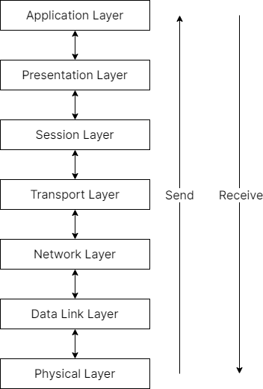

### Physical Layer

* The phyiscal layer converts any data into binary format.
* It uses signals, and also has hubs (passive, active) and switches.

### Data Link Layer

* The binary data is converted into a frame format in the data link layer.
* This layer includes bridges and gateways.
* This layer also focuses on detecting errors, and controlling data.

### Network Layer

* The binary frames are arranged into a packet in the network layer.
* This packet includes a source and destination address.
* This layer also includes fragmentation, used to fragment the data.
* Like the data link layer, the network layer also focuses on detecting errors and controlling data.

#### Associated Protocols

* **ARP**
  + The ARP (Address Resolution Protocol) is used to find IP addresses.
* **RARP**
  + The RARP (Reverse Address Resolution Protocol) is used to find physical addresses i.e. MAC (Media Access Control) addresses.
* **ICMP**
  + The ICMP (Internet Control Message Protocol) is used to report error messages and perform diagnostics in the case of an error.
* **IGMP**
  + The IGMP (Internet Group Message Protocol) allows several devices to share one IP address so they can all receive the same data.

### Transport Layer

* The transport layer sends packets to the destination address.
* It is done in a process-to-process mode.
* This layer also segments data in a process known as segmentation.
* Like the data link layer and the network layer, the transport layer also focuses on detecting errors and controlling data.

### Session Layer

* The session layer is used to establish data connections, convert segmeneted data into a session, and synchronizing data.

### Presentation Layer

* The presentation layer is used for security, allowing the encryption and decryption of data.
* It also compresses data.

### Application Layer

* The actual applications are in the application layer.
* Commonly used applications include telnet, emails, DNS, FTP (File Transfer Protocol), TFTP (Trivial File Transfer Protocol).